**Technion – Israel Institute of Technology**

**Faculty of Electrical Engineering**

Final Project Report

Project Subject

**Wavefront Mismatch Effect on SAFT for Photoacoustic Microscopy**

Students:

**Bar Weiss**

Supervisor:

**Prof. Amir Rosenthal and Zohar Or**

**Spring 2022**

Table of Contents

Abstract 3

1 Introduction 3

1.1 Photoacoustic Microscopy 3

1.2 Basic SAFT Principle 4

1.3 SAFT Techniques 6

1.4 Lateral Plane Wavefront Mismatch 8

1.5 2D Directional SAFT 10

2 Simulation Environment 12

2.1 SIR Meaning and Calculation 12

2.2 2D Scan 13

2.3 3D Scan 14

3 SAFT Results 15

3.1 2D Results 15

3.1.1 Spaced Points 15

3.1.2 Angled Lines 16

3.2 3D Results 17

4 Conclusion 18

References 18

# Abstract

In Photoacoustic microscopy Synthetic Aperture Focusing Technique (SAFT) is used to improve the lateral resolution for high NA (natural aperture) focused acoustic transducers. Seungwan Jeon et al [3] show that when imaging angled lines such as in vascular imaging, when there is a mismatch between the SAFT angle and the line angle in the image the signal quality degrades. In this work we show a similar effect when the line in angled in the depth direction. We show that the angle creates shape distortion of the imaged object as well as degradation of the SNR and signal amplitude.

# Introduction

## Photoacoustic Microscopy

Acoustic Resolution Photoacoustic Microscopy (AR-PAM) is a promising emerging technology for vascular or tumor targeted molecular medical imaging. It is a non-invasive, non-ionizing, real time imaging technique. AR-PAM typically uses an ultrasound transducer with a high acoustic numerical aperture (NA). High NA transducers achieve very good lateral resolution in the focal plane, but the resolution significantly degrades as we go further from the focal plane. Synthetic Aperture Focusing Technique (SAFT) has been introduced to overcome this degradation in the out of focus region. This technique is used when working with a focused transducer imaging method as opposed to tomographic methods that use other synthesis methods.

The Sinogram or scan is created by moving the transducer in both lateral directions, each time recording the received time signal. Each captured signal $p_{xy}\left(t\right)$ at transducer location $\left(x,y\right)$, becomes a single line in the Sinogram as follows: $S\left(x,y,t\right)=p_{xy}\left(t\right)$. The scanning can be seen in figure 1b and 1c.

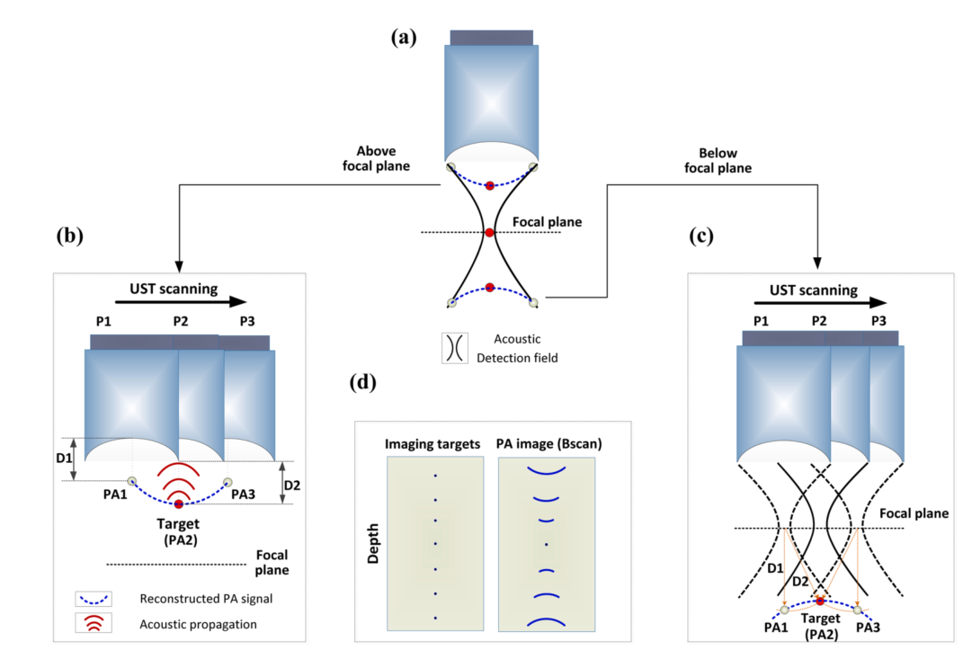

Figure 1 Graphical Illustration of signal blurring in the out of focus region (a) distorted shapes of PA signals (dashed blue lines) (b) concave shape when the target is above the focal plane (c) convex shape when the target is below the focal plane (d) comparison between imaged targets and scan results at different depths

## Basic SAFT Principle

The idea behind the SAFT algorithm is to use correlated signals to the target synthesized signal and sum them up together to sharpen the image and increase the lateral resolution. PA (Photoacoustic) signals outside the focal zone are distorted and curved away from the focus. Generally, the signals are distorted in a concave shape above the focus (figure 1b) and a convex shape below it (figure 1c) [1]. This shape is calculated by the SAFT algorithm based on the virtual detector (VD) concept as can be seen in figure 2a.

The virtual detector concept means that SAFT treats the transducer's focal point as a virtual source as seen in figure 2a. The virtual source is assumed to produce a wave propagating with a spherical wavefront within a certain angular extent. In a linear scan the sound wave generated by the virtual source at the current position will overlap with sound waves generated at adjacent positions as seen in figure 2a points $p_{1},p_{2}$ are overlapping in the two scanning positions and can be used to synthetically focus the signal.

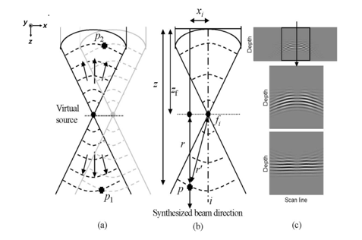

Figure 2 (a) Illustration of the VD concept (b) focusing geometry for the SAFT with a virtual source (c) at Illustration of the SAFT procedure on the bottom pane we can see the delayed version of the middle panel which straightens the lines [2]

The scan lines are delay such that correlated signals are in phase with each other like in the bottom panel in figure 2c. Figure 2b illustrates how the propagation of the synthesized beam happens. For synthesis of the point $p$ the wave propagated from the virtual source a distance $r^{'}=\sqrt{r^{2}+x_{i}}$, where $r$ is the distance of point from the virtual source in the depth ($z$) axis and $x_{i}$ is the distance of the scan line $i$ from the axis of the virtual source. The delay time is calculated based on difference in the virtual detector detection time as follows:

$Δt_{i}=sign\left(z-z_{f}\right)\frac{r-r^{'}}{c}$

Where $z_{f}$ is the focal distance and $c$ is the speed of sound. With the appropriate delay the scan lines are summed up to restore the authentic target shape as seen in figure 3.

$S_{SAFT}\left(i,t\right)=\sum_{j=-N}^{N}{S\left(i+j, t-Δt_{i}\right)}$

Where $S_{i}$ is the $i\text{-}th$ scan line in the Sinogram.

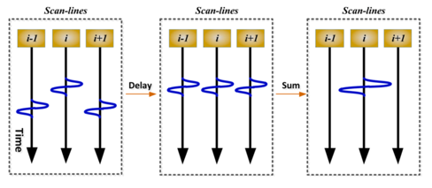

Figure 3 SAFT signal synthesis - Left: original detected scan lines, Middle: delayed versions of scan lines, Right: resulted scan lines after summation

## SAFT Techniques

Many issues arise from the basic SAFT algorithm, and hence many variations of the algorithm were created, in this section we will discuss some of the most common ones. In all methods the delay is calculated as shown in equation (1). This chapter is based on [1].

**1D-SAFT:** this technique is applied in a single direction and is the method is the one explained in the previous chapter. In this method the number of elements in the SAFT summation is depth independent.

**Coherence Factor:** this is a factor that measures the in-phase summation of each point in the SAFT sum. The coherence factor is defined as

$CF\left(i,t\right)=\frac{{\left|\sum_{j=-N}^{N}{S\left(i+j, t-Δt_{i}\right)}\right|}^{2}}{N\sum_{j=-N}^{N}{{\left|S\left(i+j, t-Δt_{i}\right)\right|}^{2}}}$

And then the coherence factor is used to suppress out of phase summation by multiplying the SAFT sum and coherence factor, as can be seen in equation (4).

$S_{SAFT-CF}\left(i,t\right)=S_{SAFT}\left(i,t\right)∙CF\left(i,t\right)$

The logic behind the coherence factor is that noise and artifacts are in-coherent and therefore will be suppressed by the CF factor as can be seen in figure 4a and b. In figure 4c we can see the advantages and disadvantages of the coherence factor. Firstly, we can see that the noise is suppressed in SAFT+CF. We can also note that the perceived shape is not cylindrical like the original and SAFT, that is because the coherence factor also suppresses signals under the noise floor as the noise will make then have a low coherence value. The coherence factor can be added to every method discussed in this chapter.

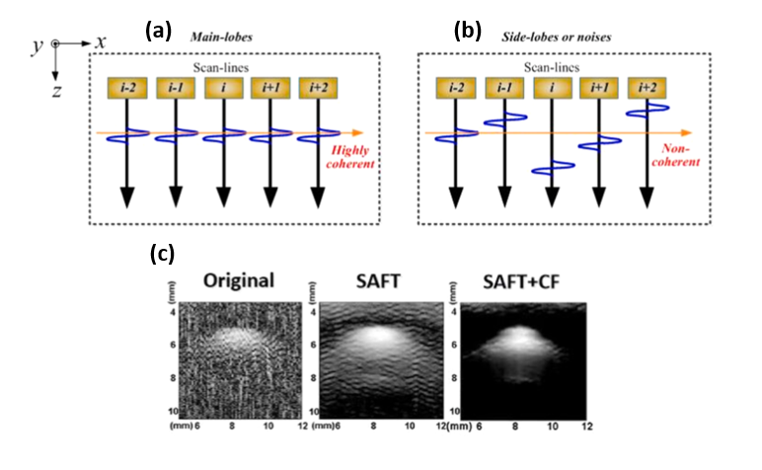

Figure 4 (a) main lobes case in coherence factor (b) side lobes, artifacts, and noises case in coherence factor (c) scan of a cylindrical object with SAFT and SAFT-CF

**SAFT-SIR:** as can be seen in figure 1d as we go further from the focus the target signal is spread over a larger arch. To cope with this phenomenon, we need to increase the summation extent in the SAFT algorithm. The summation extent is determined using the following formula:

$N\left(z\right)=\left\lfloor \frac{D_{eff}}{Δx}\right\rfloor =\left\lfloor \frac{D}{Δx}\frac{\left|z_{f}-z\right|}{z_{f}}\right\rfloor$

Where $D$ is the transducer diameter, $Δx$ is the resolution in the x-axis. Figure 5a illustrates the source of the formula, the form of the transducer focal cone is used to calculate the spread size of the arch. This geometry approximates the actual focal geometry seen in figure 5b, far from the focus this approximation is close to the real geometry. Close to the focus the approximation fails, to deal with that issue we add to the approximation a minimum summation extent $N_{min}$ and get a better approximation $N\left(z\right)=\left\lfloor \frac{D_{eff}}{Δx}\right\rfloor +N_{min}$.

We can also use a weighting map $W\left(i,t\right)$ for the summation representing the receiver sensitivity (most papers call this an SIR, but since there is another thing called SIR related to this work, we prefer to avoid this name to prevent confusion) to suppress side lobes and artifacts in the summation. An example for the sensitivity map can be seen in figure 6a and b. The previous approximation can be considered as a binary weighting map in the summation algorithm.

$S_{SAFT-SIR}\left(i,t\right)=\sum_{j=-N}^{N}{S\left(i+j, t-Δt_{i}\right)∙W\left(i+j,t-Δt_{i}\right)}$

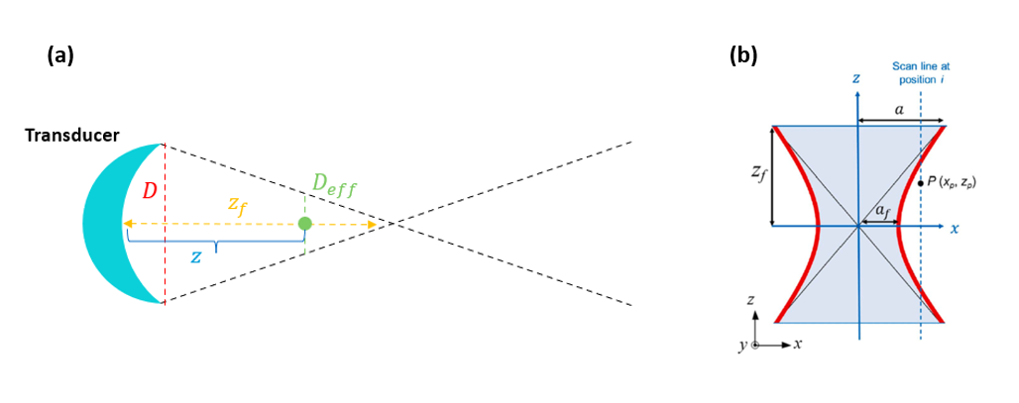

Figure 5 summation extent calculation illustration from the geometric focusing (a) linear approximation (b) actual transducer geometry

**2D-SAFT:** when working with a 3D scan as opposed to a 2D scan as discussed until now there are more signals available for applying the SAFT algorithm. Moreover, most transducers are cylindrically or spherically focus so doing only a one directional SAFT creates anisotropy in the lateral direction. To deal with that we use 2 dimensional summations instead of one dimensional to introduce symmetry. There are 2 common ways to do so, the first is called 2D cross SAFT and uses 2 separate sums as in equation (7).

$S_{2D-X-SAFT}\left(i,j,t\right)=\sum_{u=-N}^{N}{S\left(i+u,j, t-Δt_{u}\right)}+\sum_{v=-N}^{N}{S\left(i,j+v, t-Δt_{v}\right)}$

The other way is to use a circle area corresponding to the spread-out signal as in equation (8). This method is usually used with a weighting map and fits spherical transducers.

$S_{2D-S-SAFT}\left(i,j,t\right)=\sum_{u,v∈circle}{S\left(i+u,j+v, t-Δt_{uv}\right)∙W\left(i+u,j+v,t-Δt_{uv}\right)}$

In 2D we can also use a single SAFT sum in a specific angle $θ$ in the lateral plane, this can be useful when we want to correct wavefronts which don’t have spherical symmetries. For example, blood vessels exhibit cylindrical wavefronts so this technique can be useful for them, and it is used in methods such as Adaptive SAFT and 2D-Directional SAFT which will be elaborated on in chapter 1.5.

## Lateral Plane Wavefront Mismatch

In this chapter we will discuss the performance of various SAFT algorithms for 3D scans based on the results shown in [3]. First, we need to discuss the weighting maps used for SAFT-SIR. We discuss here 2 types of maps, spherical lens weighting map as seen in figure 6a and cylindrical lens maps as in figure 6b. The main difference between them is that the cylindrical lens map's amplitude decays much slower than the spherical lens'. The chosen map for SAFT depends both on the used transducer as well as the wavefronts generated by the scanned objects.

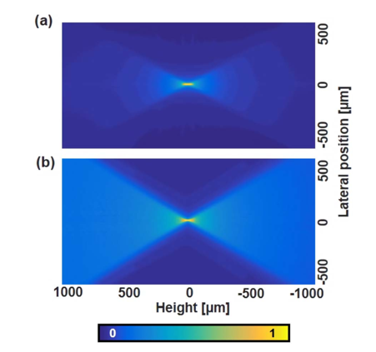

Figure 6 Receiver sensitivity of a (a) spherical lens and (b) cylindrical lens

We are interested in vasculature imaging; therefore, the scanned objects will be mostly blood vessels which are cylindrical and hence will generate cylindrical wavefronts when scanned. To compare different SAFT algorithms in this scenario we look at a phantom experiment [3] on an angled carbon fiber. The setting of this experiment can be seen in figure 7a. Figure 7c shows the results of the SAFT algorithms in Maximum Amplitude Projection (MAP). The most visually accurate correction is received for 1D SAFT-SIR with a spherical weighting map because the amplitude is constant for the entire fiber. That is because the 1D SAFT and cylindrical weights match the cylindrical wavefront generated by the cylindrical carbon fiber. The transducer used in the experiment is spherically focused so from that we conclude that in this setting the weighting map should be chosen based on the wavefront rather than the transducer itself. Therefore, when imaging cylindrical objects the ideal scenario is a cylindrical weighting map with a 1D SAFT sum at a perpendicular direction to the cylindrical object.

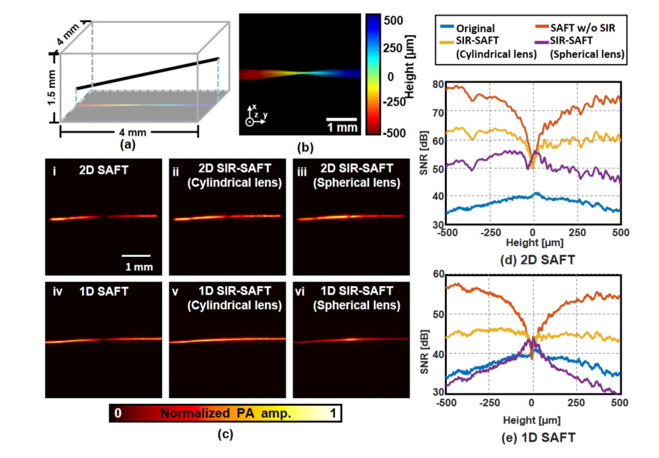

Figure 7 (a) Diagram of the experiment setting – skewed carbon fiber scanned from above (b) Depth encoded image of the carbon fiber phantom (c) various SAFT technique results of 1D and 2D SAFTs. (i) 2D SAFT without SIR (ii) 2D SIR-SAFT with cylindrical lens weighting map (iii) and a spherical lens weighting map (iv) 1D SAFT without SIR (v) SIR with cylindrical weighting (vi) with spherical weighting (d) SNR as a function of height for 2D SAFT techniques (e) SNR for 1D SAFTs

Other than that, in 2D SAFT we can see that the SNR is higher than the 1D case. The reason for that is that more elements are included in the SAFT sum and therefore, the noise level is more suppressed.

## 2D Directional SAFT

1D SAFT achieves the best lateral resolution compared to other 2D SAFT methods [3] when the ideal condition is met for imaging cylindrical objects (e.g., blood vessels). That is that the SAFT is performed at a direction perpendicular to the direction of the blood vessels. Because in the cross-section perpendicular to the blood vessel the actual delays of the signals match well with the delays calculated by 1D SAFT. The problem is that natural images of blood vessels contain multiple blood vessels at many different directions. That means that we cannot use the perpendicular direction since there are many directions in the image.

Seungwan Jeon et al [3] propose a way to merge several 1D SAFT images to form a 2D image called 2D Directional SAFT. The flow of the algorithm is illustrated in figure 8. The method first preforms 1D SAFT in $N$ different directions as seen in stage A. Then a Fourier transform is performed on the lateral planes of each 1D SAFT image (stage B). Using a filter based on the Hann window the improved frequency components for each 1D SAFT image are extracted (stage C). Then the outputs are summed in the Fourier domain (stage D), and finally we take the inverse Fourier transform (stage E) to receive the final image. This way the method allows to account for different wavefronts in the same scanned image.

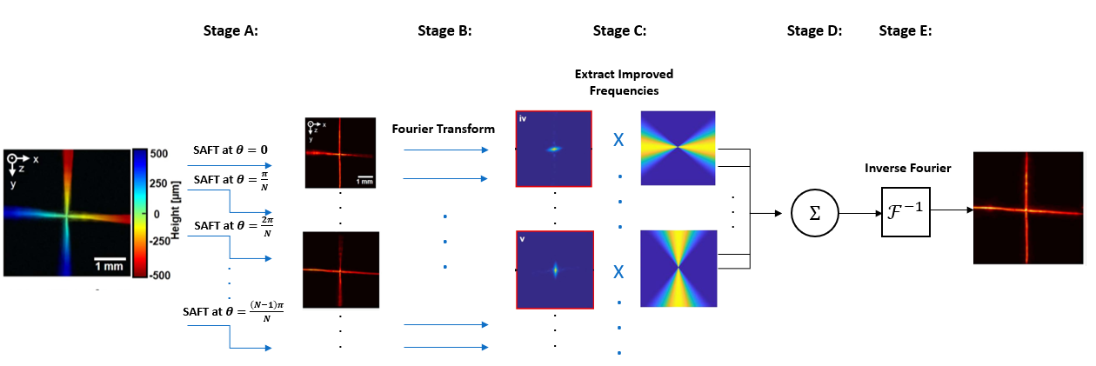

Figure 8 Schematic Explanation of the 2D-Directional-SAFT algorithm flow

Table I shows a comparison between several SAFT techniques in 2D, when imaging on a single skewed carbon fiber (like figure 7 but rotated 90 degrees). In terms of SNR uniformity, we can see that 1D SAFT under the ideal condition provides the best results, for 2D cross SAFT and 2D spherical SAFT we can see significant SNR degradation as we go further from the focus, that is again because the wavefront is cylindrical which doesn’t match the spherical wavefront assumed by these methods. In all 2D methods (except for cross SAFT) we see higher SNR as more signals are used in the summation which causes higher suppression of the noise. For the directional methods we see slower SNR degradation as we go further from the focus relatively to other 2D methods. We can see the best performance for directional SAFT for $N=2$, that is because this method gives the most weight to the actual ideal 1D SAFT in this case, which is at $θ=0$.

Table II show the compute time in the same cases as Table I, when implemented on a GTX970, NVIDIA GPU. We can see that the directional methods are far more computationally heavy then 1D SAFT and 2D cross SAFT. For spherical SAFT we see that until $N=8$ directional SAFT is faster and for higher values it is slower. But where the high processing time in Spherical SAFT is caused by many calculations caused by many elements in the SAFT sum, directional SAFT is limited by data transferring and transposing times.

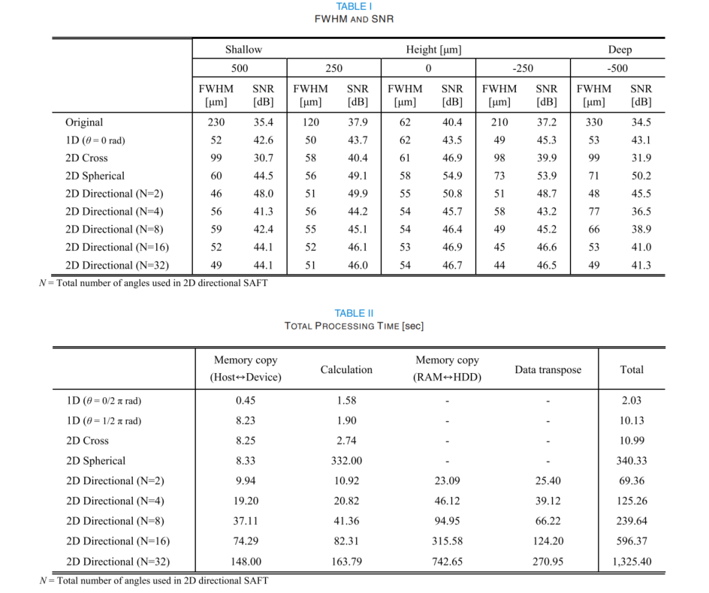

# Simulation Environment

In this work we further explore the SNR degradation when using SAFT caused by mismatch between the assumed wavefront and the actual wavefront. We explore this phenomenon using computer simulations in MATLAB. To do that we need to first create optoacoustic scans in the computer, this section discusses how these scans are created.

## SIR Meaning and Calculation

The Spatial Impulse Response (SIR) is a function $h\left(y,z,t\right)$ describing the spatial sensitivity of a transducer in receiver mode. Marcel Arditi et al [4] describe a method to calculate the SIR in several concave transducers, we use a spherical shell shaped transducer. The pressure distribution of a transmitting transducer is calculated and then by reciprocity of sound wave propagation this pressure distribution also describes the spatial sensitivity in receiving mode. The meaning of the SIR can be understood from equation (9).

$p\left(\vec{r},t\right)=-ρ\frac{∂v_{0}\left(t\right)}{∂t}*h\left(\vec{r},t\right)= -ρ∙v_{0}(t)*\frac{∂h\left(\vec{r},t\right)}{∂t}$

Where $p\left(\vec{r},t\right)$ is the pressure distribution, $ρ$ is the equilibrium density (assume to be equal to 1, since we are interested in contrast rather than exact values), and $v_{0}\left(t\right)$ is the instantaneous normal particle velocity at the face of the source. $v_{0}\left(t\right)$ in transmitting mode is the excitation of the transducer, in receiving mode it is the excitation generated by each emitting point, we assume $v_{0}\left(t\right)=δ\left(t\right)$. In this setting we get that $∂_{t}h\left(y_{0},z_{0},t\right)$ is the signal that the transducer will measure from an emitting source at $\left(y_{0},z_{0}\right)$. To avoid numerical errors when we calculate the temporal derivative of the SIR, we convolve it with a derivative of a gaussian rather than taking a simple numerical derivative. We used a $\frac{25um}{c}$ wide gaussian in this work.

In my code the function Sph_F_exact_wrapper.m implements the SIR calculation for a spherical transducer.

## 2D Scan

The algorithm for a 2D scan receives an image $I\left(y,z\right)$ representing the radiation amplitude of the imaged object, and the transducer's parameters. There are two scanning options in 2D, Y scan and X scan. These options refer to the scanning direction, meaning whether the image is scanned in the y direction or x direction as illustrated in figure 9a and b.

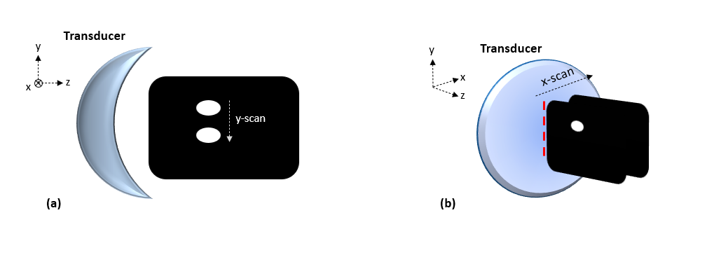

Figure 9 Scanning Illustrations (a) Y scan (b) X scan

**Y scan:** this scan is performed by translating the image each time and calculating the contributions from the SIR according to the image. The formula can be seen in equation (10).

$S\left(y,t\right)=\sum_{i=1}^{N}{\sum_{j=1}^{M}{∂_{t}h\left(y_{i},z_{j},t\right)I\left(y_{i}-y,z_{j}\right)}}$

By translating the image in each iteration, we achieve a scan in the y direction and a similar effect to moving the transducer as a real scan operates. The function sinogram.m implements this scan.

**X scan:** this scan is performed by translating the SIR each time in the x direction to achieve movement of the transducer in the $x,y$ plane. For the SIR translation to save computations and still use a 2D SIR we can use the symmetry of a spherical transducer. Since the transducer is symmetric in the $x,y$ plane, the SIR will also be symmetric in the $x,y$ plane. That means the SIR only depends on $r=\sqrt{x^{2}+y^{2}}$ i.e., $h\left(x,y,z,t\right)=h\left(r,z,t\right)$. Hence the scan follows equation (11).

$S\left(x,t\right)=\sum_{i=1}^{N}{\sum_{j=1}^{M}{∂_{t}h\left(\sqrt{y_{i}^{2}+x^{2}},z_{j},t\right)I\left(y_{i},z_{j}\right)}}$

The function x_scan.m implements this scan.

## 2.3 3D Scan

For a 3D scan in principle, we need to use a 3D image $I\left(x,y,z\right)$ and calculate the 3D SIR $h\left(x,y,z,t\right)$, and then the 3D scan will be given by the following three-dimensional sum.

$S\left(x,y,t\right)=\sum_{k=1}^{L}{\sum_{i=1}^{N}{\sum_{j=1}^{M}{∂_{t}h\left(x_{k},y_{i},z_{j},t\right)I\left(x_{k}-x,y_{i}-y,z_{j}\right)}}}$

For this work we use a simpler version with a two-dimensional sum, to save computation time. This is achieved by assuming that the image is only two-dimensional, meaning its width in the x direction is a single pixel $I\left(x,y,z\right)=δ\left(x\right)I\left(y,z\right)$. By plugging this in equation (12) we get the following 2D sum:

$S\left(x,y,t\right)=\sum_{i=1}^{N}{\sum_{j=1}^{M}{∂_{t}h\left(\sqrt{y_{i}^{2}+x^{2}},z_{j},t\right)I\left(y_{i}-y,z_{j}\right)}}$

This way we create 3D scans in a computationally lighter manner. The function scan_3D.m implements this scan.

# SAFT Results

All the results are for a focal length of $F=12.3mm$ and transducer diameter of $D=24.6mm$, meaning an NA of 45 degrees. Gaussian noise is added uniformly to the sinogram with a $σ$ of 15% of the maximum amplitude of the sinogram.

## 2D Results

### 3.1.1 Spaced Points

First, we do a straightforward analysis of the SNR degradation of spaced points at different distances from the focus. Since the points have a spherical wavefront, we expect symmetry in the wavefront and therefore the degradation in SNR should be relatively low. The results are shown in figure 10. We can see that the basic SAFT (figure 10b) performs well visually away from the focus and that the signal in the focus is below the noise level. For the SAFT SIR (figure 10c) the signal in the focus is still weaker than the ones out of the focus but it can be noticed. The SAFT SIR with the weighting map (figure 10d) accounts for the decrease in amplitude further from the focus, therefore the signal in the focus is relatively higher and can be noticed.

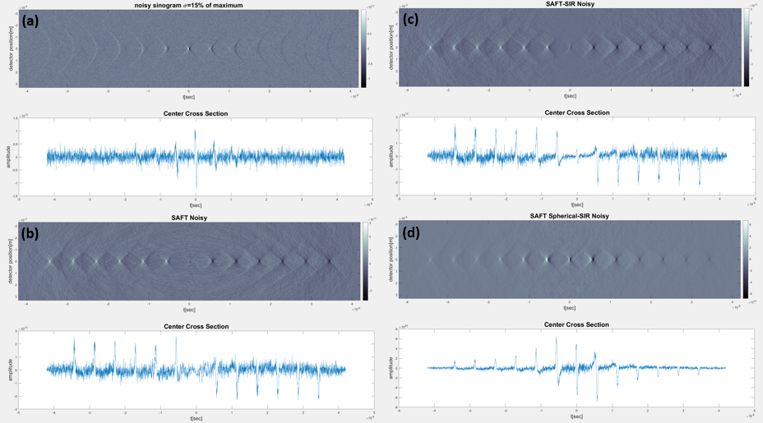

Figure 10 SAFT performance on spaced out points (a) Raw sinogram data (b) Basic SAFT (c) SAFT SIR without weighting map (d) SAFT SIR with spherical lens weighting map, below each image there is a cross section of the center cross section

Figure 11 shows the SNR of the spaced points in each method. We can see that SAFT SIR improves upon basic SAFT near the focus and their SNR becomes closer as we go further from the focus. That is because the number of elements in the sum is the difference between the methods, and as we go further from the focus the number of elements in the summations becomes similar and hence the SNR as well. We can see that the SAFT SIR with weighting map has the best SNR but acts fairly like SAFT SIR without the weighting map.

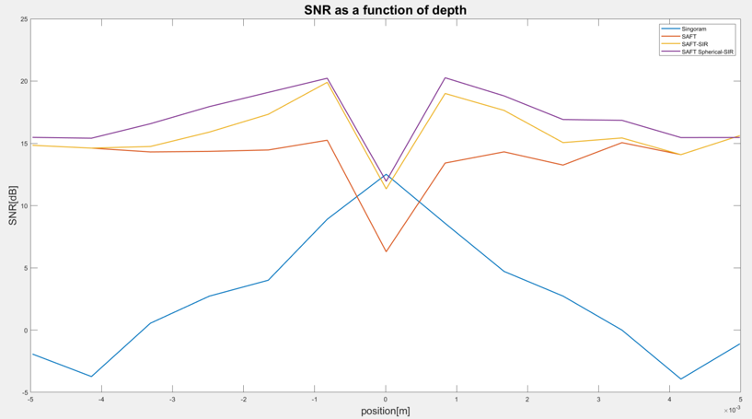

Figure 11 SNR of the spaced points for each SAFT method shown is figure 10

### 3.1.2 Angled Lines

Now we want to further explore the idea of wavefront mismatch in SAFT correction. Here we use image angled lines in the depth direction rather than in the lateral plane as explored by Seungwan Jeon et al [3]. Figure 12 shows the results of performing SAFT SIR on angled lines at different angles. As expected, since 1D SAFT matches cylindrical wavefronts at the lateral plane, the signal quality degrades as the angle of the line increases. Figure 12c shows that as we go further from the focus the signal quality degrades as well. Figure 12c compared to 12a and 12b also show greater distortion of the object shape. While for 10 and 20 degrees the lines are clear and straight, for 30 degrees as we go further from the focus the lines become curved and smeared. It is important to note that the SAFT here is performed in the y direction which is not the ideal condition for 1D SAFT described earlier. That is because the simulation is in 2D and therefore there is no data in the ideal direction, which is the x direction, in the 3D results it is performed with the ideal condition.

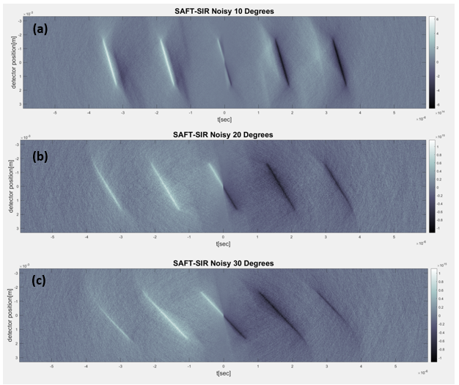

Figure 12 Angled lines SAFT-SIR results without weighting map, lines at angles (a) 10 degrees (b) 20 degrees (c) 30 degrees. The original images are the same as figure 15a-c, and the system is as illustrated in figure 13

## 3.2 3D Results

In this section we explore the performance of 1D SAFT on angled lines in the z direction in the three-dimensional case. **That allows us to use the ideal condition when performing 1D SAFT, meaning summing in the perpendicular direction to the lines [3] i.e., the x direction. The system setting can be seen in figure 13**, several lines are placed at an angle towards the transducer to explore the effect of wavefront mismatch in the depth direction in 3D.

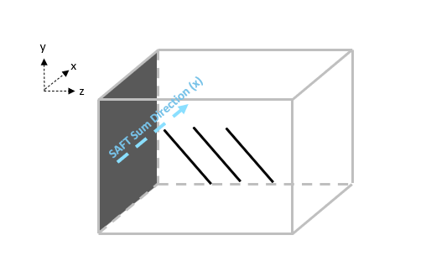

Figure 13 System illustration, several angled lines in the depth direction, the gray side marks the transducer's direction. The 1D SAFT summation direction is illustrated by the blue arrow

The results are shown using **MAP (Maximum Amplitude Projection) in the x direction**, which means to take the maximum of the absolute value in the x direction. That is **opposed to [3] (results in figure 7) that show results in MAP in the depth direction**. In their representation depth direction degradation cannot be seen and this is an important viewpoint especially since we are angling the lines in the depth direction. Figure 14 shows the results for angled lines in 3D when using SAFT SIR without a weighting map.

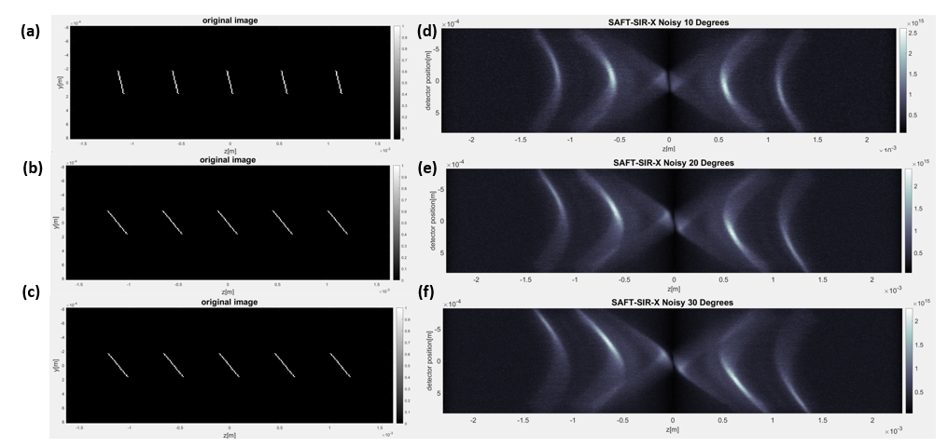

Figure 14 MAP of 1D SAFT SIR in 3D for angled lines at (d) 10 degrees (e) 20 degrees (f) 30 degrees under the ideal condition for 1D SAFT (summation in x direction), (a)-(c) show the original scanned images for (d)-(f) respectively.

Here as opposed to the 2D case we see that the signal decays faster, at 1.5mm the signal is already relatively weak. We can notice that the object shape is distorted for all cases, the shape of the objects around the edges of the lines is curved. This curvature can’t be seen when displaying the data in MAP in the depth direction since it is distortion in the depth plane as shown by figure 16. Another effect is the distortion of the line location, and as the angle increases the line moves from the center of the image. In figure 14a-c show the original scanned objects compared to the imaged locations in figure 14d-f. **We see that as the angle increases the location of the imaged lines is further from the actual location**. Before the focus the line becomes higher in the y direction, and further from the focus it becomes lower in the y direction. The reason for this is that the wavefront isn’t parallel to the transducer plane. The resulting raw signal shapes from the scan are shown in figure 15. For a 0 angle line as in figure 15a the arch shape matches the assumptions of the SAFT algorithm. For the 10 and 20 degree (figure 15b and c) lines on the other hand, the shape of the arch is distorted. The resulting arches are angled like the original scanned lines, **which creates mismatch between the assumed summation arch used by the SAFT algorithm and the actual arches**.

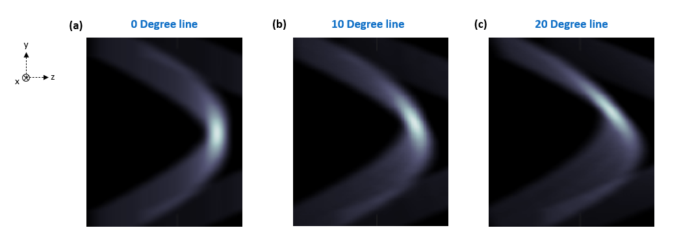

Figure 15 raw signal shape comparison of (a) 0 degree ,(b) 10 degree and(c) 20 degree lines

Figure 16 shows another point of view for the results in figure 14b. We look at MAP in the z direction on the 20 degrees line after the SAFT in the x direction. We can see that in the focus (3rd line) the signal is clear and well positioned in the center of the image. As we go further from the focus the strongest signal is no longer at the center of the line as it should be, but rather it is on the side. This is again caused by the arch shape mismatch to the assumed shape of the SAFT algorithm.

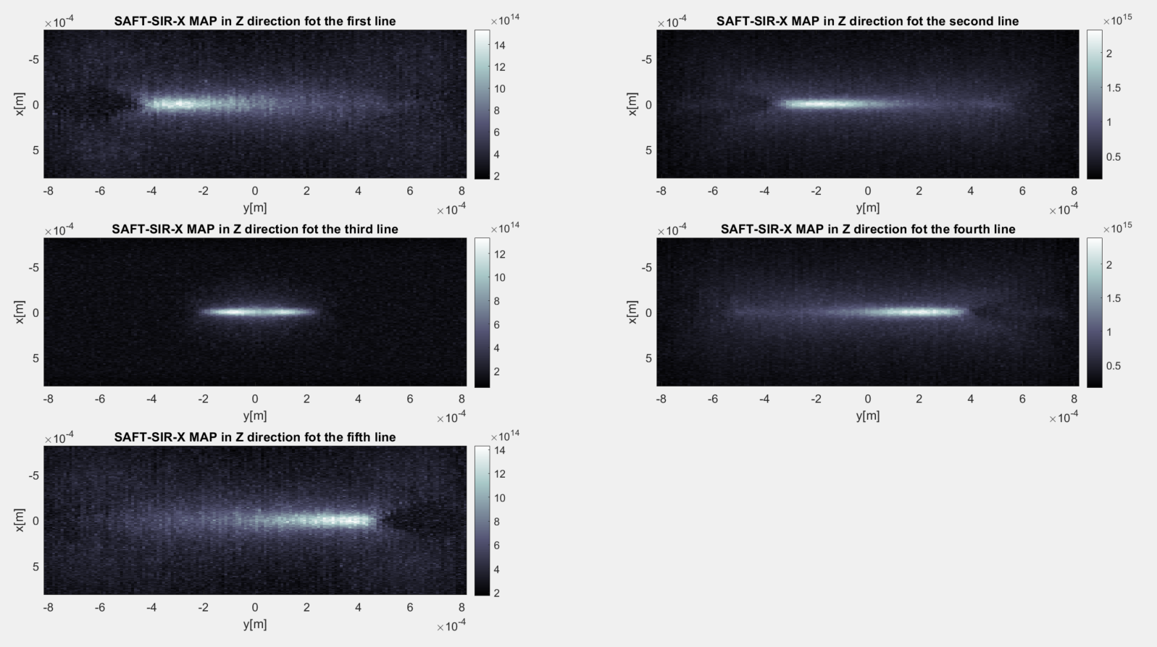

Figure 16 Z direction MAP of the SAFT reconstruction in x direction of each line for 20 degrees angled lines. The numeration of the lines is from left to right in figure 14b.

Figure 17 shows the same depth MAP projections as figure 16 just for a line parallel to the transducer plane for comparison. We can see that a parallel line also exhibits smearing of the signal as the line center moves from the focal plane. The apparent difference is that the maximum of the lines is at the center of the image, matching the actual line position. While for the angled lines the maximum shifts to the sides of the image for lines further from the focus. The z direction MAP shows more clearly the signal intensity throughout the line. For the parallel line we see a more uniform intensity for the line for all distances from the focus. for the angled line on the other hand, the signal value isn’t uniform, and the maximum intensity point moves from the center of the line to the side.

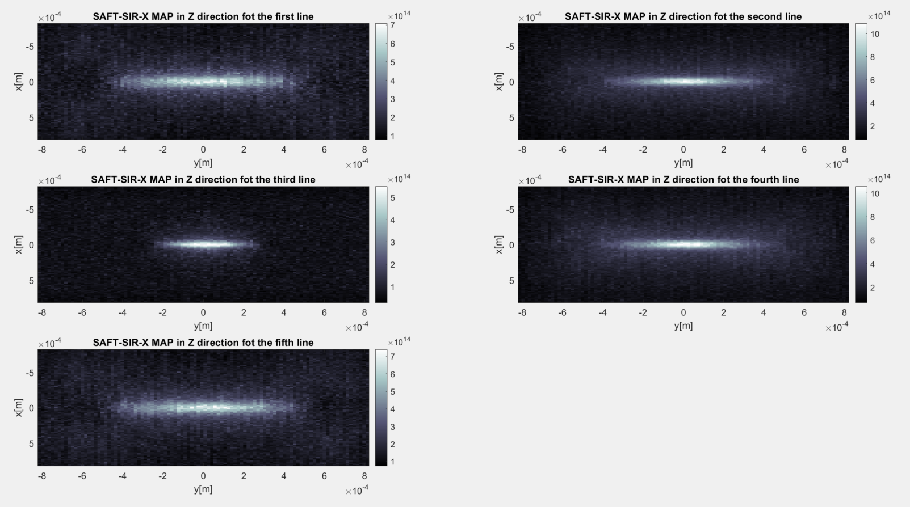

Figure 17 Z direction MAP of the SAFT reconstruction in x direction of each line for parallel lines. The numeration of the lines is from left to right in figure 14b

## Experiment Recreation

In this section we recreate Seungwan Jeon et al's experiment [3] shown in figure 7, using our simulation environment. We place 3 lines at an angle of 14 degrees, one line is placed with its center at the focus, and the 2 other lines are placed with their center at a 2mm distance from the focus one closer to the transducer and one further. Figure 18 shows the results of the experiment recreation with SAFT summation in the x direction. In figure 18a we see the results of MAP in the x direction, as stated before the lines not centered at the focus where centered a z distance of 2mm. But the result show line centers are further than 2mm. **In figure 18b we see the displacement in the y direction compared to the actual line position shown in the dashed red line**. In b(ii) we see that the line is centered at y=0 but for b(i) the centered at y<0 and at b(iii) it is centered at y>0.

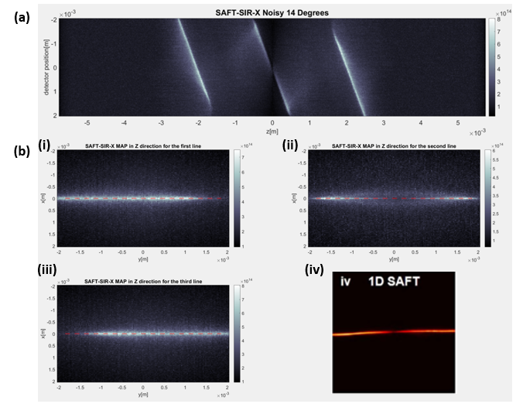

Figure 18 Experiment recreation results, the central line is a recreation of the experiment from figure 7 and two more lines are placed at 2mm distances from the focus then SAFT is performned in the x direction. (a) the results of SAFT shown in MAP in the x direction. (b) the results of MAP in the z direction for each line segment, the red dashed line marks the original line placement. (i) the closest line to the transducer (ii) the line whose center is at the focus (iii) the line farthest from the transducer (iv) the original experiment results to compare to (ii)

To further express the results of the experiment we repeat the experiment with lines at a 30 degrees angle. The results of the SAFT reconstruction are shown at figure 19. As expected the displacement of the line becomes more severe.

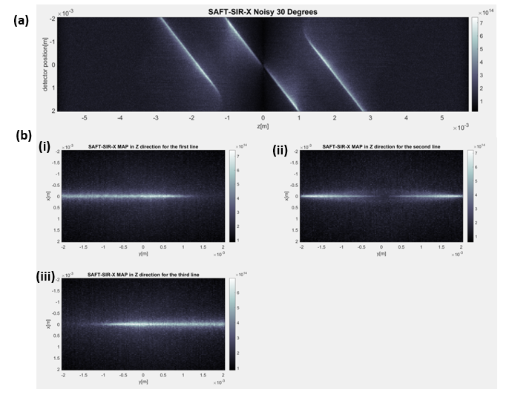

Figure 19 Experiment recreation with 30 degree angled lines (a) MAP in the x direction (b) MAP in the depth direction for each one of the lines (i) leftmost line (ii) middle line (centered at the focus) (iii) rightmost line

# Conclusion

From the 2D results on the spaced points we understand that there is a fundamental degradation in SNR when using SAFT, but it is relatively slow - around 1[dB/mm]. Visually the signal is clear for all inspected distances. When looking at the angled lines though we can see clear visual degradation for the 30 degrees angled line further from the focus. The results also show that as the mismatch becomes more severe i.e., the angle of line is bigger, the signal quality degrades, and the shape of the imaged objects are distorted.

For the 3D case we see two main artifacts caused by increased depth angles. First, is that the positioning of the reconstructed lines is distorted. As shown in figures 14 and 16 the depth angle causes the reconstructed object to be poorly positioned. Second, the signals become more smeared as the angle increases and the signal becomes weaker. In addition, the signal shape around the edges is distorted and curved. This effect is in the depth direction and therefore cannot be seen in MAP projections in the depth direction like in [3]. For that reason, it is important to look at projections in other directions and not just the depth direction when analyzing SAFT's performance.

For all the reasons above, the positioning of the blood vessels is very important when imaging and we need to place the transducer according to their position such that the angle in the depth direction is small. SAFT algorithms that sum arches angled also in the depth directions can be considered, but that introduces another degree of freedom to the SAFT sum direction. Meaning that algorithms such as 2D directional SAFT [3] will have to include more 1D SAFTs and will increase the run time fundamentally.

For lines parallel to the transducer plane the quality is good for all the inspected distances as can be seen in figure 18. **When the lines aren’t parallel, there is a distortion effect in the positioning of the line as seen in figures 16 and 18**. When the center of the line is at the focus, the reconstructed line is well positioned. But when the center isn’t at the focus, we see the positioning distortion. That is the reason the results in [3] shown in figure 7 are good even though the line has a ~14 degrees angle. That is because the lines are centered at the focus as in the third line in figure 17, we see there that even for a higher angle of 20 degrees the MAP is clear and uniform.

Figure 16 relatively to figure 18 show that **for short lines** **the effects of object distortion and poor positioning are stronger than for long lines**. Based on that understanding we can think of a scenario where depth angled lines will result in poor reconstruction. This scenario is shown in figure 20, a main blood vessel with 2 branching smaller vessels angled towards and further from the transducer. The two branching vessels are small lines angled in the depth direction and therefore will exhibit distortion effects like the ones shown in figure 16.

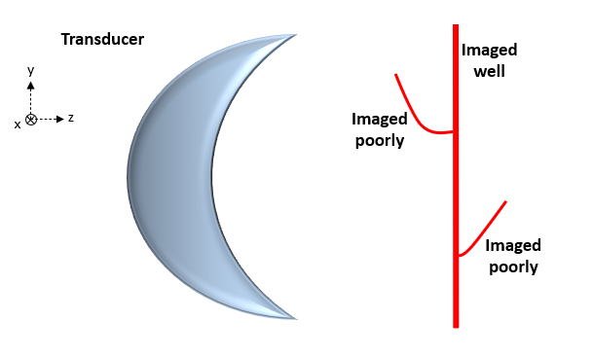

Figure 20 Illustration of a scenario where depth angles will result in poor imaging the red lines represent a branching blood vessel.

The effect of depth angle shows when imaging complex geometric shapes. We show here an example of imaging a knot. Jake Turner et al [5] show results of imaging a knot and applying SAFT to reconstruct the image. The results of the experiment are shown in figure 21, from the volumetric rendering we can see that the knot has an angle in the depth direction. **The reconstruction at positions where the knot is curved** **has a weaker signal** for both figure 21b and 21c. This can be explained with the SAFT wavefront mismatch since the knot is angled in the lateral and depth directions at these positions. **Curved lines can be approximated as several short lines at different angles and hence they suffer from wavefront mismatch related effects as shown in this work.**

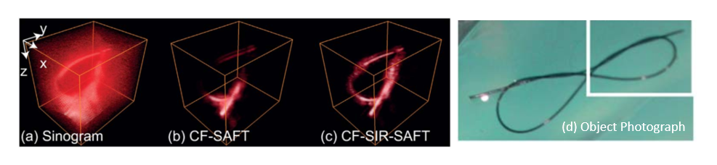

Figure 21 Experiment of imaging a knotted suture. (a)-(c) Volume rendering of the optoacoustic data (a) sinogram (b) CF-SAFT result (c) CF-SIR-SAFT. (d) a photograph of the knot, the white rectangle marks the focused part.

# References

1. Rongkang Gao et al, "Achieving Depth-Independent Lateral Resolution in AR-PAM Using the Synthetic-Aperture-Focusing-Technique", Photoacoustics (2022)
2. Marcel Arditi et al, “Improved Synthetic Aperture Focusing Technique with Applications in High-Frequency Ultrasound Imaging", IEEE Transaction on Ultrasonics (2004)
3. Seungwan Jeon et al, "A Novel 2-D Synthetic Aperture Focusing Technique for Acoustic-Resolution Photoacoustic Microscopy", IEEE Transactions on Medical Imaging (2019)
4. Arditi, Marcel, F. Stuart Foster, and John W. Hunt, "Transient fields of concave annular arrays," Ultrasonic imaging 3.1 (1981): 37-61.‏
5. Turner, Jake, et al. "Improved optoacoustic microscopy through three-dimensional spatial impulse response synthetic aperture technique." Optics letters 39.12 (2014) 3390-3393.